Ian Kilgore

10-25-2017

Texture comparison

Tactile texture:

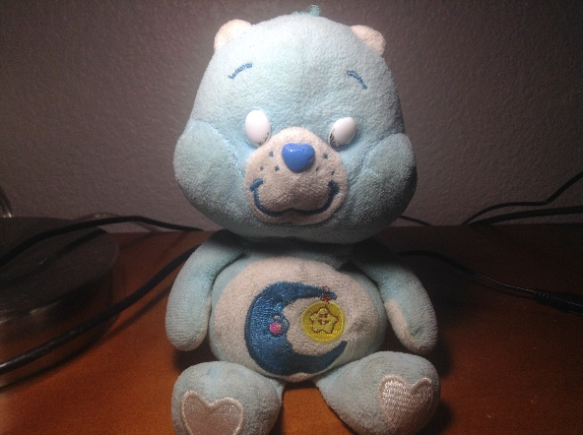

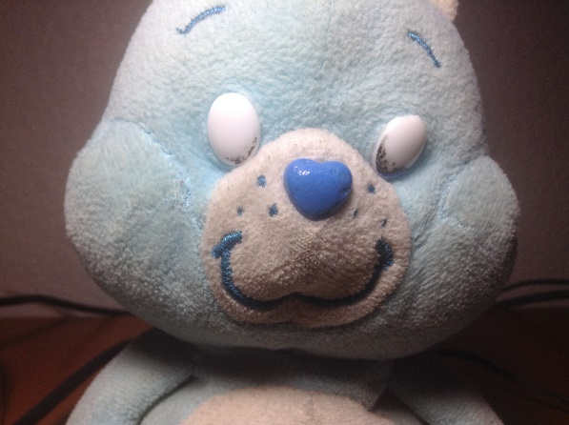

Here is my carebear, his texture is very soft and fluffy. This tactile texture makes people feel happy, comforted, and reminds them of being young. This texture would be useful in marketing to children or moms for their kids, or reminding people of their youth.

Visual texture:

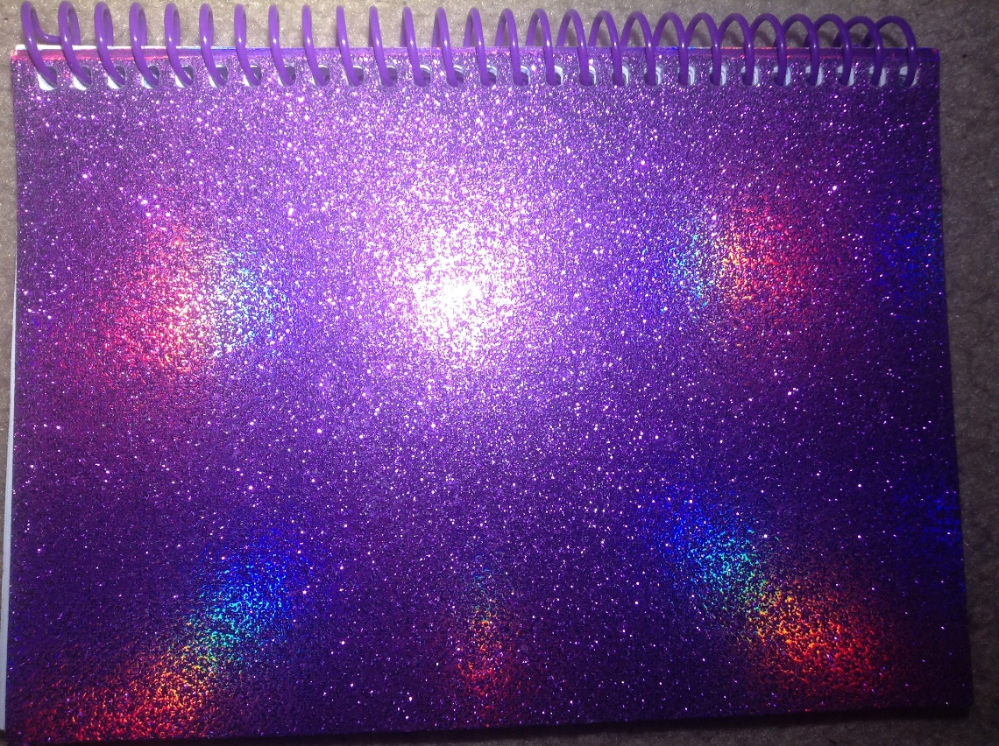

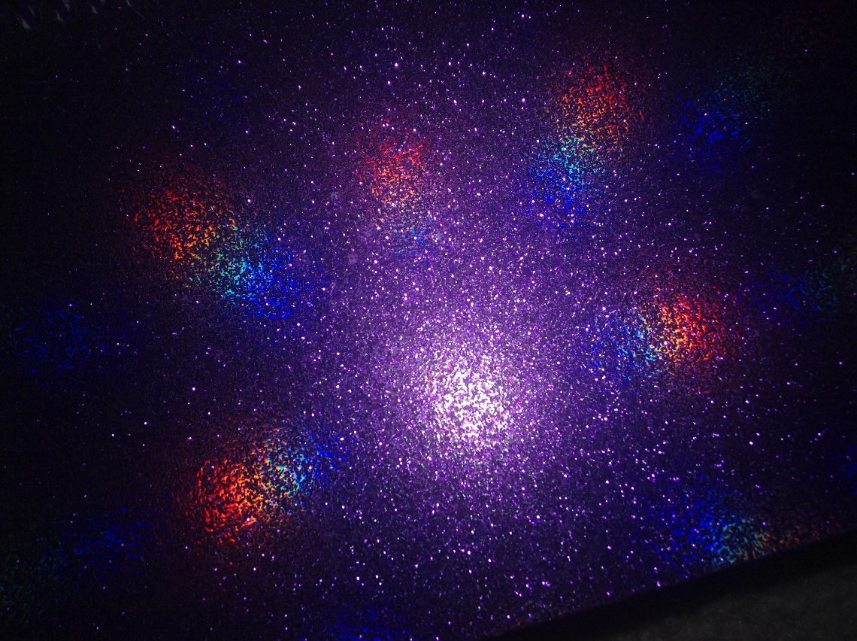

Although the texture on this notebook cover is totally flat and therefore only visual, it still sends a strong message to the person looking at it. It is very sparkly with bright colors and reflects rainbow light from a bright flashlight when I photographed it. Even though you can’t feel the sparkles or the rainbow lights, this visual texture makes the viewer feel like they are in a new age or futuristic place. This texture would be useful in marketing technology or science fiction to kids and adults.